Getting started with Python on Series 60 FP2

Introduction

This document provides information to install Python on Series 60 SDK and on Series 60 phones. The document is intended to lead the reader through the whole installation process and gives an introduction build the own Python scripts and standalone programs. Note this document focuses on the Series 60 FP2, other editions or feature packs will require different installation files.

Requirements

To develop applications for Series 60 phones (models 6600, 6630, 6670, 7610) the files as listed below are required. All the files can be downloaded from http://kom.aau.dk/project/mobilephone/Python/ and need to be installed:

- PythonForSeries60_1_2_for_2ndEd_FP2_SDK.zip
- PythonForSeries60_for_2ndEd_SIS.zip
- python-2.4.2.msi (alternatively a text editor can be used)
- s60_2nd_fp2_sdk_msb.zip

Installing Python on Series 60 SDK

The SDK comes with an emulator for the mobile phone, which is useful to test the applications before installing them on the mobile device. This section presents the steps necessary for the installation of the Python execution environment which includes a plug-in for Nokia Series 60 SDK emulator able to emulate Python scripts.

Installing Python on Series 60 SDK and Nokia SDK on a Windows OS PC

Step 1: Installing Nokia Series 60 SDK

- Uncompress the file s60_2nd_fp2_sdk_msb.zip and run the file setup.exe
- Start the installer program and follow the instructions.

Step 2: Installing Python for Series 60 SDK

- Uncompress the file PythonForSeries60_1_2_for_2ndEd_FP2_SDK.zip and run the file Python_for_2ndEd_FP2_SDK.exe
- Start the installer program and follow the instructions. By default the installer installs the emulator files and some examples into the directory:
<EPOCROOT>\Epoc32\Release\wins\udeb\z\system\apps\PYTHON
where <EPOCROOT> is the root folder of your SDK installation.

Step 3: Installing Python Release

- Run the file python-2.4.2.msi and follow the instructions.

Installing Python on a Series 60 Mobile Device

There are two ways of installing Python for Series 60 on a Series 60 device:

- Nokia PC Suite software (see http://www.nokia.com/ for more information) that allows transferring file from a mobile device to a PC and vice versa. Usually it is included in the phone package.
- Infrared or Bluetooth technology

If you use Nokia PC Suite and have associated files of SIS type with the PC Suite application, click the file PythonForSeries60.SIS after unzipped PythonForSeries60_for_2ndEd_SIS.zip.

You can also install Python for Series 60 directly from a PC using the Infrared port or Bluetooth wireless technology.
To install Python for Series 60 with Infrared or Bluetooth technology:

- Close all applications in your device before you start the installation.
- Connect your PC and your phone via an Infrared or a Bluetooth connection.
- Right-click PythonForSeries60_for_2ndEd_SIS and send the file to your phone.
- Follow the instructions of the installation procedure.
- After installation, an application called Python is visible in the phone’s (or an emulator’s) main menu. It allows to launch the Python execution environment.
- Select the Python icon to start Python.

Writing a simple script

The following example shows how to write a simple “Hello World!” Python script. The example uses a Python for Series 60 module named appuifw.
For more information about it, see Python for Series 60 Platform API Reference (http://kom.aau.dk/project/mobilephone/Python/API_Reference_for_Python.pdf).

  - 1. Open a text editor.
  - 2. Write the following lines (the first line is a comment):
# Hello
from appuifw import *
note(u"Hello World!", "info")

3. Save the file as hello.py
Running a Python script on the emulator

To run a Python script on the Nokia Series 60 SDK emulator it is necessary to follow the following steps:

- Save the hello.py file in the folder: <EPOCROOT>\Epoc32\Release\wins\udeb\z\system\apps\PYTHON
- Start the Nokia Series 60 SDK emulator (see Figure 1)

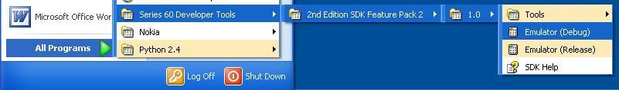
Figure 1 – Opening Nokia emulator

- Select the Python icon and click on it
- Click on “Select->Run script
- Click on hello.py
- The Figure 2 shows the screen shots of all the steps

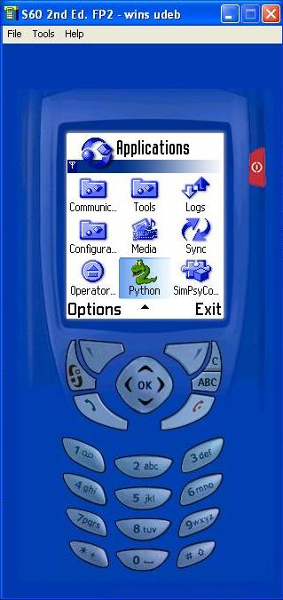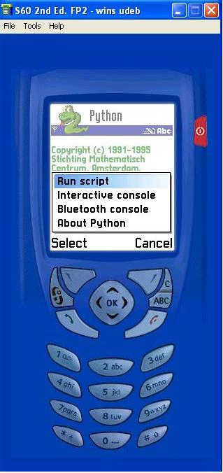
Step 1: Select Python icon Step 2: Select>Run script

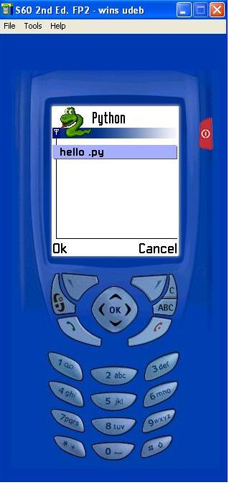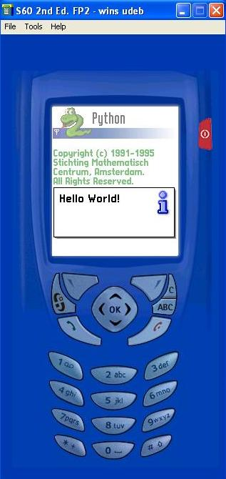
Step 3: Click on hello.py Step 4: Hello World screen

Figure 2 – Hello World script on the Nokia emulator

Bluetooth Console

Another alternative for developers to test and debug applications without using the emulator is to use the Bluetooth console. In facts it connects the PC directly to the Python environment on the phone.
All is needed is to switch the Bluetooth on the phone and to have on the phone a HyperTerminal opened and listening to the COM port.
Make sure you have the bluetooth settings of the PC's bluetooth software correctly set:
- right click on bluetooth icon -> choose open bluetooth settings to open them.
- choose Options tab, make sure "Turn discovery on" is selected
- choose COM ports tab, make sure an COM port as "incoming" direction available, if not click add and created an incoming COM port

Let us have a look at the steps needed to run the “Hello World!” script via Bluetooth Console:
- Open a HyperTerminal on the PC listening to the port assigned to the Bluetooth serial service:
- go to Accessories -> Communications -> HyperTerminal
- give a name and choose an icon, press ok, then choose in the "connect using"
field the COM port of your "incoming port", press ok
- make the HyperTerminal active by clicking the "call" button.
- Select the Python icon and click on it from the phone
- Start the Bluetooth Console on the phone: Options->Bluetooth console (see Figure 3)
- After the device discovery, connect to the PC
- On both the phone’s an HyperTerminal’s screen a message will appear (see Figure 4)
- Type on the HyperTerminal the following code as shown in Figure 5:
import appuifw
appuifw.note(u”Hello World!”,’info’)
- On the phone’s screen will pop up the Hello World message as shown in the Figure 6.
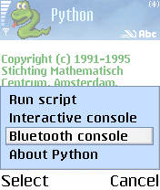

Figure 3 – Running Bluetooth console

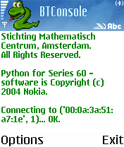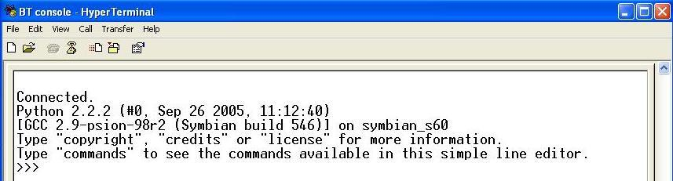

Figure 4 – Connection between the PC and the phone

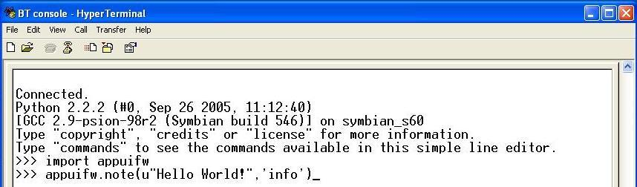

Figure 5 – Typing code on the HyperTerminal

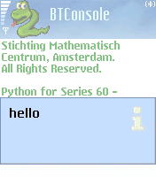
Figure 6 – Hello World pop-up on the phone

It is possible to use the Bluetooth console to retrieve information from the phone. It follows an example that shows how to get the information about the GSM location of the phone:
- Follow the steps from 1 to 5 of the previous example
- Type on the HyperTerminal the following code as shown in Figure 7:
import location
location.gsm_location()
- On the screen of the HyperTerminal the Mobile Country Code, Mobile Network Code, Location Area Code and Cell ID appear.

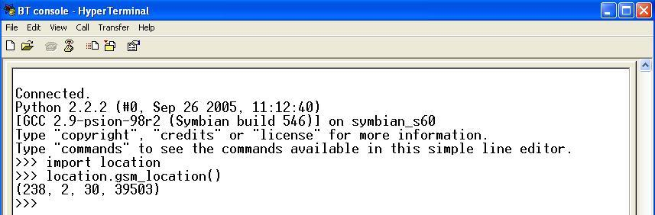
Figure 7 – Location information

Installing a Python script on the phone

The following section describes one of the ways to install a script on the phone:

- Connection the PC and the phone via Bluetooth or Infrared.
- Right-click the file you want to install and send it to your phone.
- Allow the Python Installer to install the Python script.

During the installation you can choose whether the file has to be installed as a "Python script" (under Python execution environment) or as a "Python lib module" (library component). In this case you should install the file as a "Python script". After the installation the application can be started following the steps 3 to 5 of the previous section.

Creating stand alone applications

The following section describes how to create stand alone applications. These applications work only if Python for Series 60 is correctly installed on the device.
The Python for Series 60 SDK installation package provides a utility (py2sis) for creating a SIS file to be installed on Symbian Series 60 devices.

- Download and install Active Perl for SDK build tools
- Include in the Path Environment Variable of Windows the location of uidcrc.exe (by default it should be located in C:\Program Files\Common Files\Symbian\tools) and the location of py2sis.exe (by default it should be located in C:\Nokia\Tools\Python_for_Series_60\py2sis)
(System Properties>Advanced>Environment Variables; Click on Path in the System Variables and then Edit, as shown in the Figure 7)
- Open a “Command Prompt” window
- Use the command: (see Figure 8)

py2sis <src> [script] [--uid=0x1234567]

  - <src> : the path of the script
  - [script] : the name of the script
  - [--uid=0x1234567] : UID can be chosen during development from the range of 0x01000000 0x0fffffff (for more information about UID, see Series 60SDK help documentation)

- The SIS file is now created in the same folder as py2sis.exe
- Establish a connection between your PC and your phone.
- Right-click the file, send it to the phone and install it.

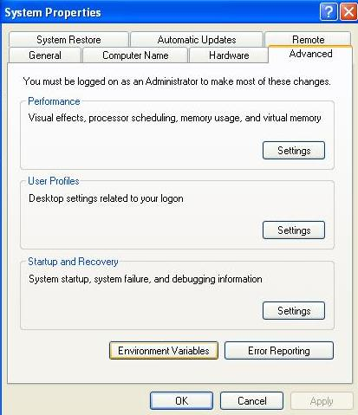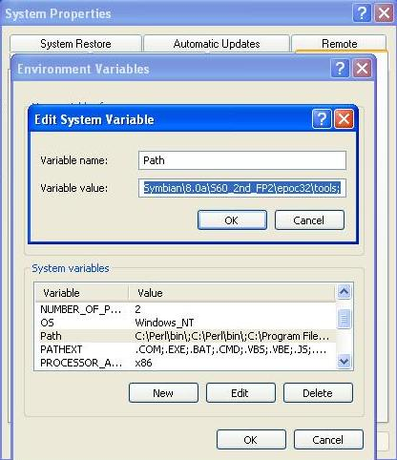

Figure 7 - Setting Environment Variables in Windows XP

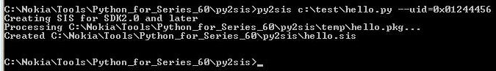
Figure 8 - Creating SIS file

Other phones can support Python for Series 60, but different files need to be downloaded and installed.

